AI Assignment-01

Jeetu Mehra
U24AI032

Question 1 : Consider a map given in image.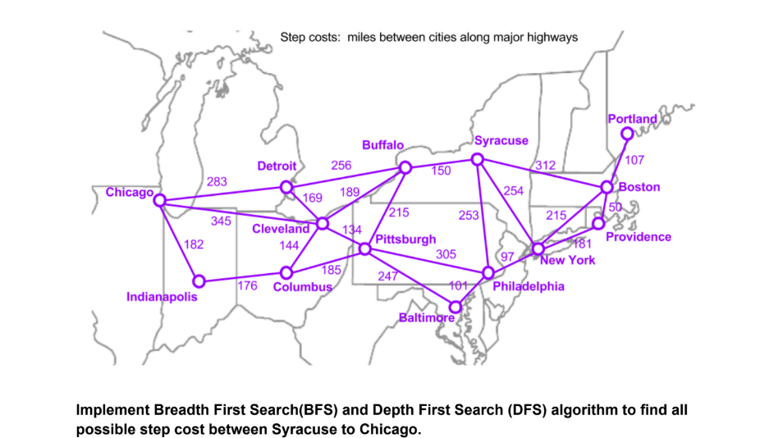
Code:
#include <iostream>
#include <vector>
using namespace std;

//NODE STRUCT
struct Node {
int cityIndex;
int totalCost;
vector<int> path;
};

// CUSTOM QUEUE
class Queue {
private:
Node arr[1000];
int front, rear;

public:
Queue() {
front = 0;
rear = -1;
}

bool isEmpty() {
return front > rear;
}

void enqueue(Node x) {
arr[++rear] = x;
}

Node dequeue() {
return arr[front++];
}
};

// BFS FUNCTION
void BFS(vector<pair<int,int>> graph[], int start, int end, vector<string>& cities) {
Queue q;
q.enqueue({start, 0, {start}});

cout << "\nAll BFS paths from " << cities[start]
<< " to " << cities[end] << ":\n";

while(!q.isEmpty()) {
Node curr = q.dequeue();
int u = curr.cityIndex;

if(u == end) {
for(int idx : curr.path) {
cout << cities[idx] << " -> ";
}
cout << "END | Total Distance: "
<< curr.totalCost << " miles\n";
continue;
}

for(auto &neighbor : graph[u]) {
int v = neighbor.first;
int cost = neighbor.second;

bool visited = false;
for(int idx : curr.path) {
if(idx == v) {
visited = true;
break;
}
}

if(!visited) {
vector<int> newPath = curr.path;
newPath.push_back(v);
q.enqueue({v, curr.totalCost + cost, newPath});
}
}
}
}

// DFS FUNCTION
void DFS(
int u,
int end,
vector<pair<int,int>> graph[],
vector<bool>& visited,
vector<int>& path,
int cost,
vector<string>& cities
) {
visited[u] = true;
path.push_back(u);

if(u == end) {
for(int idx : path) {
cout << cities[idx] << " -> ";
}
cout << "END | Total Distance: "
<< cost << " miles\n";
}
else {
for(auto &neighbor : graph[u]) {
int v = neighbor.first;
int w = neighbor.second;

if(!visited[v]) {
DFS(v, end, graph, visited, path, cost + w, cities);
}
}
}

path.pop_back();
visited[u] = false;
}

// MAIN FUNCTION
int main() {
vector<string> cities = {
"Chicago","Detroit","Cleveland","Buffalo","Syracuse",
"Pittsburgh","Columbus","Indianapolis","New York",
"Philadelphia","Baltimore","Boston","Providence","Portland"
};

vector<pair<int,int>> graph[14];
int weight[14][14] = {0};

weight[0][1]=283; weight[1][0]=283;
weight[0][2]=345; weight[2][0]=345;
weight[0][7]=182; weight[7][0]=182;
weight[1][2]=169; weight[2][1]=169;
weight[1][3]=256; weight[3][1]=256;
weight[2][3]=189; weight[3][2]=189;
weight[2][5]=134; weight[5][2]=134;
weight[2][6]=144; weight[6][2]=144;
weight[3][4]=150; weight[4][3]=150;
weight[3][8]=312; weight[8][3]=312;
weight[4][8]=254; weight[8][4]=254;
weight[4][11]=312; weight[11][4]=312;
weight[4][9]=253; weight[9][4]=253;
weight[5][6]=185; weight[6][5]=185;
weight[5][9]=305; weight[9][5]=305;
weight[6][7]=176; weight[7][6]=176;
weight[6][9]=247; weight[9][6]=247;
weight[8][9]=97; weight[9][8]=97;
weight[8][11]=215; weight[11][8]=215;
weight[8][12]=181; weight[12][8]=181;
weight[9][10]=101; weight[10][9]=101;
weight[10][11]=161; weight[11][10]=161;
weight[11][12]=50; weight[12][11]=50;
weight[12][13]=107; weight[13][12]=107;

for(int i=0;i<14;i++){
for(int j=0;j<14;j++){
if(weight[i][j]!=0){
graph[i].push_back({j, weight[i][j]});
}
}
}

BFS(graph, 0, 4, cities); // Chicago → Syracuse

cout << "\nAll DFS paths from Chicago to Syracuse:\n";
vector<bool> visited(14, false);
vector<int> path;
DFS(0, 4, graph, visited, path, 0, cities);

return 0;
}

Output:
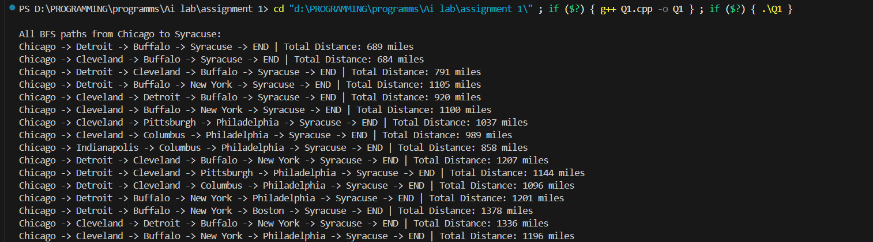

Question 2 : Consider a social media network as given below. Find BFS and DFS tree.
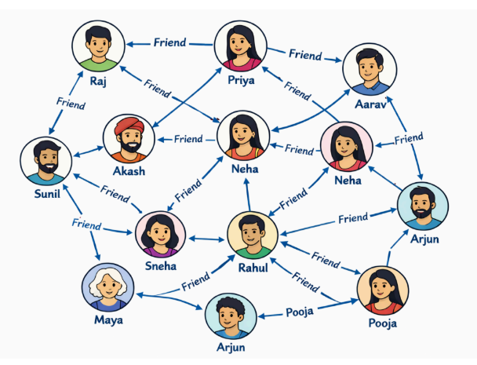

Code:
#include <iostream>
#include <vector>
using namespace std;

// NODE STRUCT
struct Node {
int person;
vector<int> path;
};

// CUSTOM QUEUE
class Queue {
private:
Node arr[100];
int front, rear;

public:
Queue() {
front = 0;
rear = -1;
}

bool isEmpty() {
return front > rear;
}

void enqueue(Node x) {
arr[++rear] = x;
}

Node dequeue() {
return arr[front++];
}
};

// BFS FUNCTION
void BFS(vector<int> graph[], int start, vector<string>& names) {
Queue q;
vector<bool> visited(names.size(), false);

q.enqueue({start, {start}});
visited[start] = true;

cout << "\nBFS Tree starting from " << names[start] << ":\n";

while (!q.isEmpty()) {
Node curr = q.dequeue();
int u = curr.person;

cout << names[u] << " -> ";

for (int v : graph[u]) {
if (!visited[v]) {
visited[v] = true;
q.enqueue({v, curr.path});
cout << names[v] << " ";
}
}
cout << endl;
}
}

// DFS FUNCTION
void DFS(
int u,
vector<int> graph[],
vector<bool>& visited,
vector<string>& names
) {
visited[u] = true;
cout << names[u] << " -> ";

for (int v : graph[u]) {
if (!visited[v]) {
DFS(v, graph, visited, names);
}
}
}

// MAIN FUNCTION
int main() {
vector<string> names = {
"Raj","Priya","Aarav","Sunil","Akash",
"Neha1","Neha2","Sneha","Rahul",
"Arjun1","Maya","Arjun2","Pooja"
};

vector<int> graph[13];

graph[0] = {1,3};
graph[1] = {0,2,4};
graph[2] = {1,6,9};
graph[3] = {0,7};
graph[4] = {1,5};
graph[5] = {4,8};
graph[6] = {2,8};
graph[7] = {3,8,10};
graph[8] = {5,6,7,11};
graph[9] = {2,12};
graph[10] = {7};
graph[11] = {8,12};
graph[12] = {9,11};

BFS(graph, 0, names); // BFS from Raj

cout << "\nDFS Tree starting from Raj:\n";
vector<bool> visited(13, false);
DFS(0, graph, visited, names);

return 0;
}

Output:
